.

## Data Cleaning, Transformation, and Workflow in Power BI

The image you shared shows the **Power Query Editor**, which is like the "kitchen" of Power BI. This is where you prepare your raw ingredients (your data) by cleaning them up and shaping them before you start cooking (analyzing) them.

### 🥗 Data Cleaning

**Data cleaning** is all about getting rid of the mess and making sure your data is accurate and reliable. Think of it like washing vegetables before you chop them.

Based on your image, these steps are related to cleaning:

* **Removed Top Rows:** Imagine your data sheet had some extra notes or empty lines at the very top that aren't part of the actual information. This step **deletes those unnecessary rows** so only the real data remains.
* **Filtered Rows:** This step is like picking out only the good parts you need. In your example, it seems the data was **filtered to include only population data for the years 2010 to 2019**, excluding data from other periods. This ensures you're only working with relevant information.

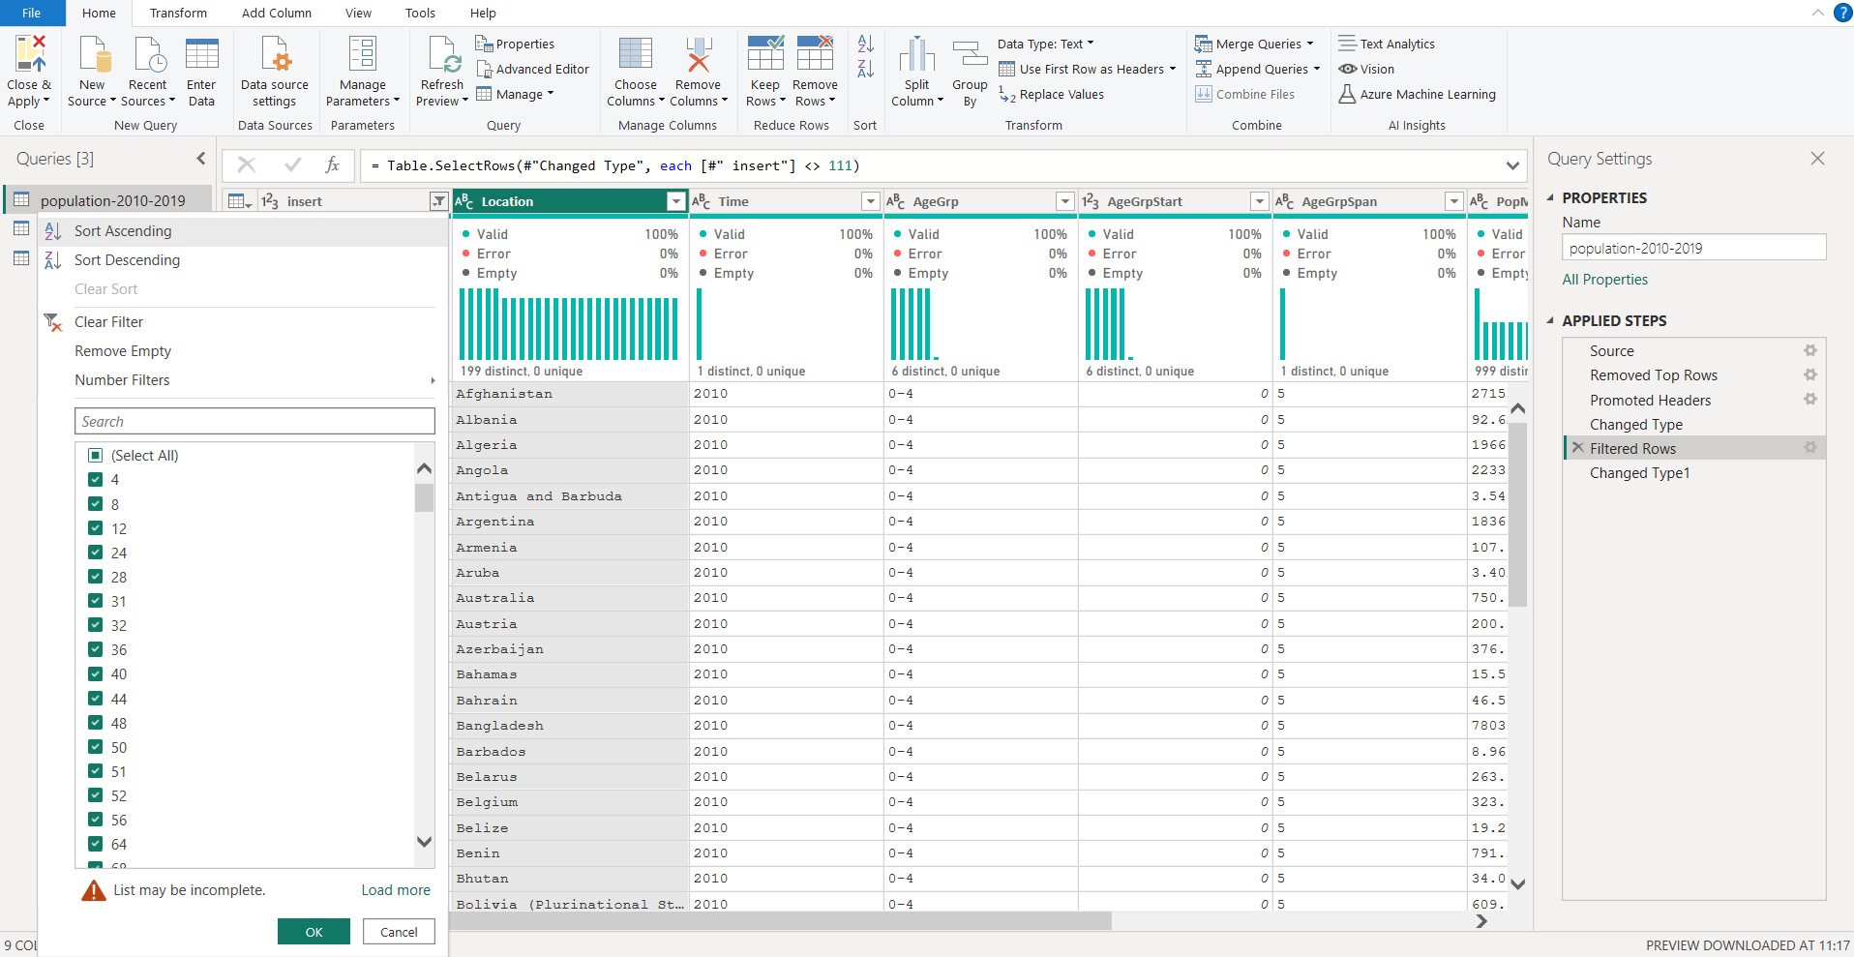

### ✨ Data Transformation

**Data transformation** means changing the data's shape or type to make it more useful for analysis. It's like chopping, dicing, or slicing your vegetables into the right sizes and shapes.

From your image, these steps are about transformation:

* **Promoted Headers:** Often, the first row of your data contains the names for each column (like "Location" or "Time"). This step **takes that first row and makes them the official column names**, making your data much easier to understand and work with.
* **Changed Type:** Every piece of data has a "type" – like a number, text, or date. This step **sets the correct type for each column**. For example, it might ensure "Popln" (population) is recognized as a number so you can do calculations, and "Location" is recognized as text. This prevents errors when you try to use the data later.

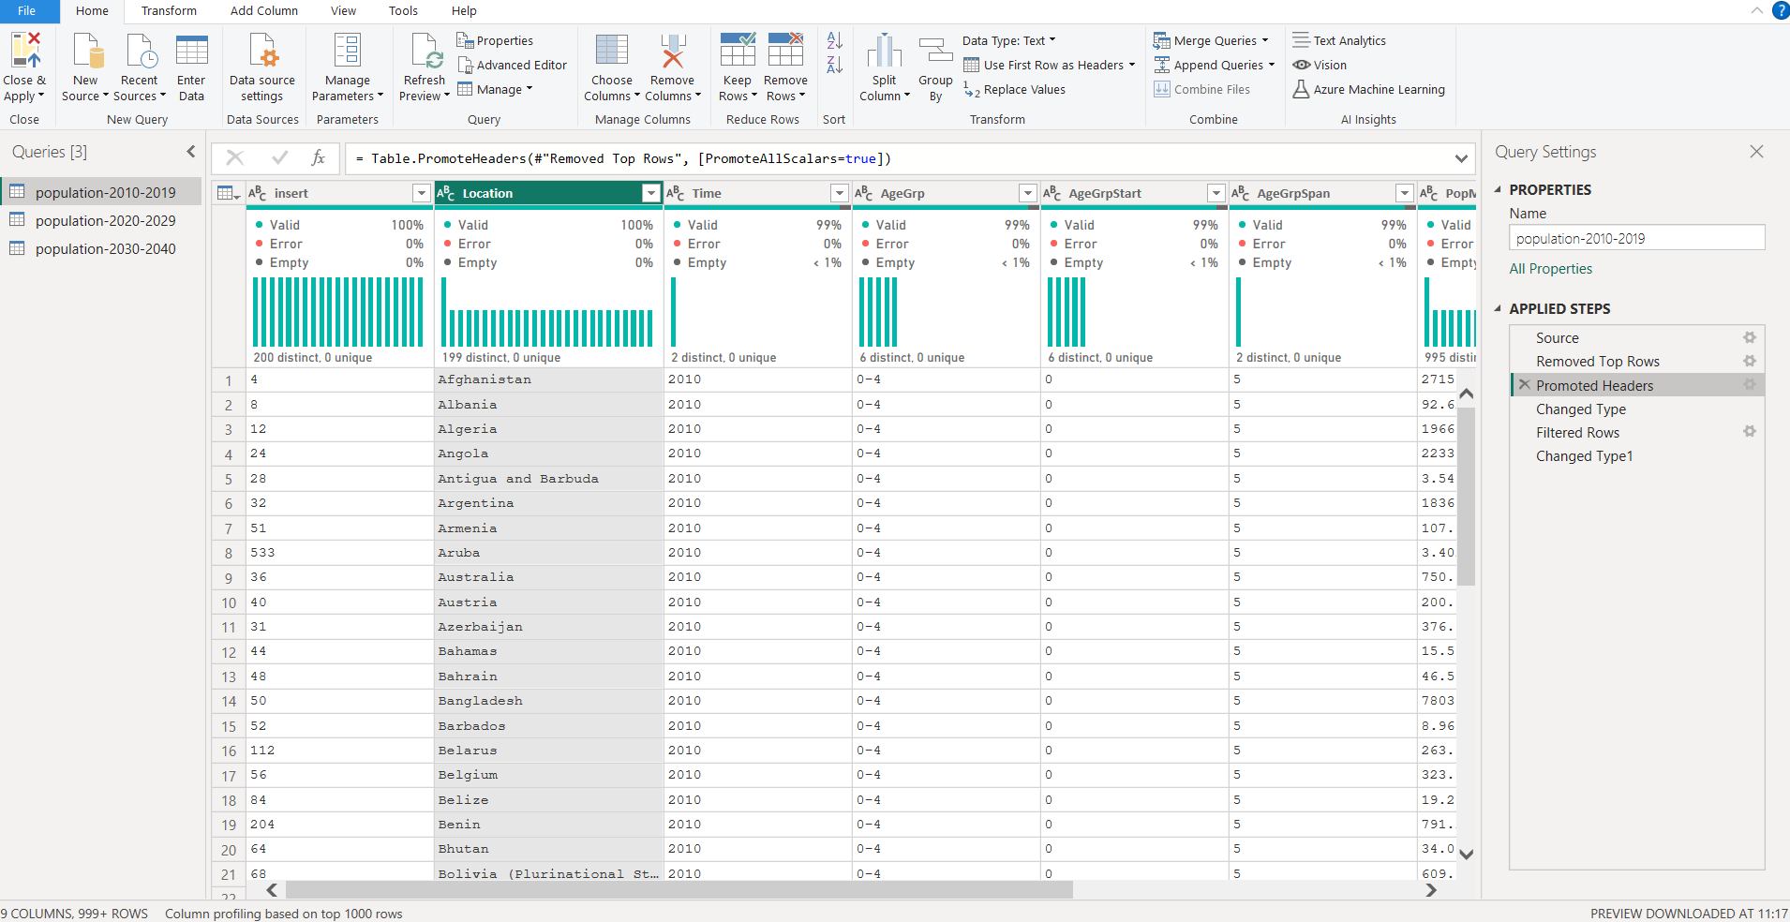

### 🔄 Power BI Workflow (in Power Query Editor)

The "APPLIED STEPS" pane on the right side of your image shows the **workflow** in Power Query Editor. This is super important because it records *every single change* you make to your data, in the exact order you made them.

Here's how the workflow generally goes:

1. **Connect to Data ("Source"):** You start by connecting to your data source (e.g., an Excel file, a database). This is the very first step in the workflow.
2. **Apply Steps Sequentially:** As you perform cleaning and transformation actions (like removing rows, promoting headers, filtering, or changing types), Power Query Editor **automatically adds each step to the "APPLIED STEPS" list**.
3. **Review and Modify:** You can easily click on any step in the list to see how the data looked at that point, or even delete or reorder steps if you make a mistake or want to change something. This makes data preparation very flexible and forgiving!
4. **Iterative Process:** Data preparation is often an **iterative process**. You might apply a few steps, check the data, realize you need another cleaning step, apply it, and then continue with more transformations. All these changes are neatly recorded.

In short, the "APPLIED STEPS" list is your **history book of data preparation**, making it transparent, repeatable, and easy to adjust your data for analysis in Power BI.

